I cannot print or access Wi-Fi or scan my NFC card

Issue
If the Wi-Fi settings do not display a “New Connection” button, despite the Wi-Fi dongle being correctly inserted into the back of the kiosk, the issue may be related to the USB Lock setting.

Resolution Steps
- Access System Settings
  - From the Control Panel, press the System button.
- Check USB Lock Status
  - If the USB Lock is toggled ON, switch it to OFF.
  - Press Close, then power cycle the kiosk (turn it off and back on).
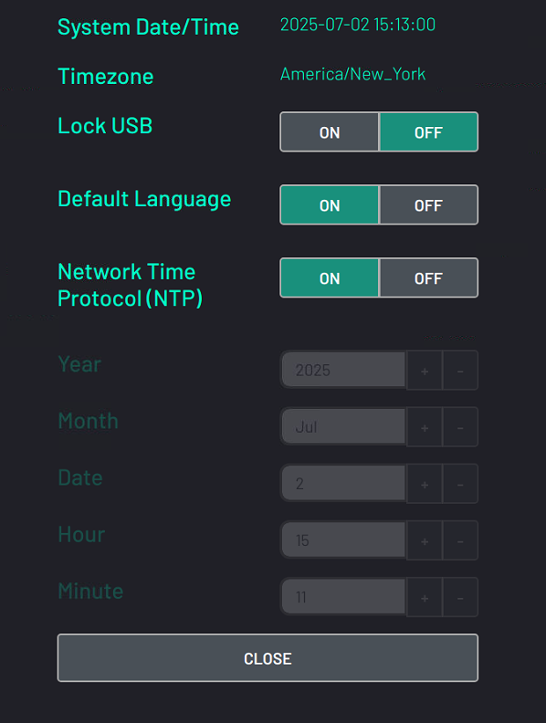
- Verify Network Settings
  - After the restart:
    - Confirm the USB Lock remains OFF.
    - Check that the “New Connection” button is now visible in the Network Settings.
- USB Device Detection
  - The USB Lock setting also affects detection of other USB-connected devices such as:
    - VTAP Readers use by the eGym solution
    - Printers
  - If these devices are not recognized, ensure the USB Lock is disabled as the first troubleshooting step.
- Remote Restart via Ethernet
  - If the kiosk is connected via Ethernet, you can apply the USB Lock change remotely:
    - Disable the USB Lock.
    - Use TeamViewer to access the command terminal.
    - Run the following command: sudo supervisorctl restart all
    - This command simulates a reboot and applies the new USB Lock setting without needing to power cycle the unit.

